**Character Storyboard – School Child (Jimmy Stone)**

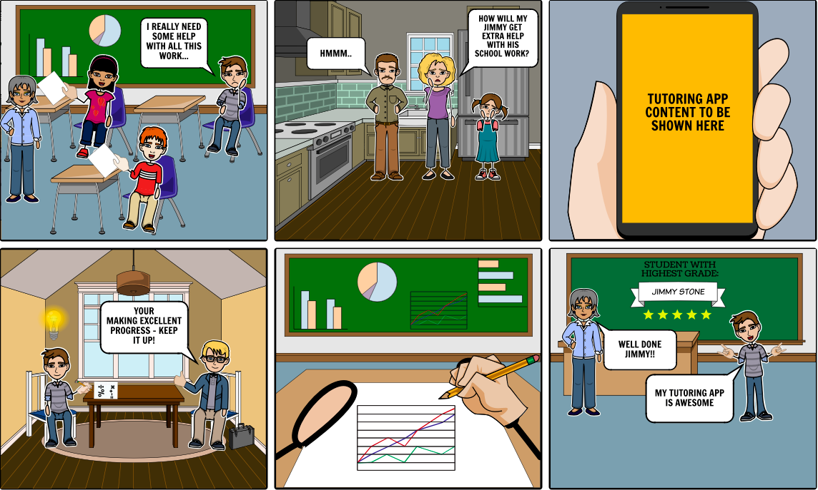

**1**

**2**

**3**

**4**

**5**

**6**

1. Jimmy is really struggling in his maths class and is quite upset by the fact that his other classmates are more advance than he is in the subject.
2. Jimmy’s family; Mum, Dad & younger Sister have acknowledged his difficulties in Maths and are now extremely worried they will not be able to find the required help he needs.
3. One of Dad’s colleagues at work has been using a newly developed tutoring app for his daughter who also faces the same struggles’ as Jimmy does at school. Shortly after explaining how the app work, Dad quickly downloads the app on his phone to find a local tutor who can help his son.
4. The tutor (who is a university student) arrives at Jimmy’s home to offer his support at a time that has been requested via the app.
5. Jimmy is currently in class sitting his maths test which is set out by his teacher on a monthly basis. He is using his knowledge taught by his personal tutor at home.
6. Jimmy’s teacher announces that he has received the highest marks out of his whole class in the test. He is extremely pleased with his achievements and now feels confident in his abilities in Maths thanks to the tutoring app.